System Requirements Statement (SRS) –

Home Rental

1. Introduction 3

2. Functional Requirements 4

2.1 Tenant Module 5

2.2 Owner Module 7

2.3 admin Module 10

2.4 UseCaseDiagram..................................................................................................................................11

1. **Introduction**

This document explains the system requirements and scope for developing Home Rental.

Home Rental could divide the three main modules->Tenant part,Property Owner part, Admin part.

1. **Functional Requirements**

The Account part of Home Rental has three modules which are divided 13 processes described as below.

|  |  |  |
| --- | --- | --- |
| **No** | **BRS requirement ID** | **Description** |
| **2.1** | **Tenant Module** | |
| **2.1.1** | **F1** | **Register Process** |
| **2.1.2** | **F2** | **Login Process** |
| **2.1.3** | **F3** | **Search property** |
| **2.1.4** | **F4** | **View Owner Info** |
| **2.1.5** | **F5** | **Pay for Subscription** |
| **2.2** | **Owner Module** | |
| **2.2.1** | **F6** | **Register** |
| **2.2.2** | **F7** | **Login Process** |
| **2.2.3** | **F8** | **Add Property** |
| **2.2.4** | **F9** | **Delete Property** |
| **2.2.5** | **F10** | **Pay for subscription** |
| **2.2.6** | **F11** | **Browse own Properties** |
| **2.2.7** | **F12** | **Requested tenants** |
| **2.3 Admin Module** | | |
| **2.3.1** | **F13** | **Login Process** |
| **2.3.2** | **F14** | **View All property** |
| **2.3.3** | **F15** | **View All tenants** |
| **2.3.4** | **F16** | **View All owners** |
| **2.3.5** | **F17** | **Delete users** |
| **2.3.6** | **F18** | **Delete Properties** |
| **2.3.7** | **F19** | **Manage Transaction(Report)** |

* 1. **Tenant Module**
* Tenants are the user of system who wants to rent a property.
* They are able to view and search the properties.
  + 1. **Register Process**
* Home Rental compels to login before viewing owner information. So, Home Rental should provide the function which makes tenant to create new account.
* When tenant creates new account, the function demands following information described as below.

1. Email
2. Password
3. First Name
4. Last Name
5. Area
6. Address
7. Phone No
8. Payment
   * All items are compulsory demanded.
9. Email

* The Email should be unique. If the Email corresponds with not case-sensitive to other which is previously registered, the Email should not be registered as an account.

1. Password

* The Password has a constraints which makes the Password consists of more than or equal 8 and less than or equal 16 characteristics including characters described as below.
* Numeric figure (at least one)
* Capital alphabet (A-Z)(at least one)
* Small alphabet (a-z)(at least one)
* Special character (#, $, %, &, etc.) (at least one)
* The Password is masked by dummy characters. The re-entering Password is demanded.

1. First name

* First name has the constraints which contain max size of 15 characters.

1. Last name

* First name has the constraints which contain max size of 15 characters.

1. Area

* Area should be selected from database

1. Address

* Address has the constraints which contain max size of 200 characters.

1. Phone no

* Phone number has the constraints which contain exactly 10 digit.
  + 1. **Login Process**
* The user authentication demands Email and Password. The Email and the Password should be checked as below.
  + The Email and the Password should be existed and correct.
* If The Email and the Password are not equal to what the user has registered, the user authentication cannot be provided.
* The “Home Page” provides the some items described as below.

1. A trigger to logout
2. A trigger to profile
3. A trigger to Search Properties
   * 1. **Search Property**

* Search conditions are described as below.

1. Price Range
2. Location
   * 1. **Pay for Subscription**

* After Registering we are providing option pay for subscription.
* Only after a successful payment user can login to our system.
  + 1. **Request For Owner Info**
* Tenant can demand information about the property owner(restricted number of requests to owners info is given after registration).
  1. **Owner Module**
     1. **Register Process**
* Home Rental compels to login before adding a property So, Home Rental should provide the function which makes owners to create new account.
* When owner creates new account, the function demands following information described as below.

1. Email
2. Password
3. First Name
4. Last Name
5. Area
6. Address
7. Phone No
8. //Payment
   * All items are compulsory demanded.
9. Email

* The UserID should be unique. If the Email corresponds with not case-sensitive to other which is previously registered, the Email should not be registered as an account.

1. Password

* The Password has a constraints which makes the Password consists of more than or equal 8 and less than or equal 16 characteristics including characters described as below.
* Numeric figure (at least one)
* Capital alphabet (A-Z)(at least one)
* Small alphabet (a-z)(at least one)
* Special character (#, $, %, &, etc.) (at least one)
* The Password is masked by dummy characters. The re-entering Password is demanded.

1. First name

* First name has the constraints which contain max size of 15 characters.

1. Last name

* First name has the constraints which contain max size of 15 characters.

1. Area

* Email should be valid

1. Address

* Address has the constraints which contain max size of 200 characters.

1. Phone no

* Phone number has the constraints which contain exactly 10 digit.
  + 1. **Login Process**
* Home Rental always compels owner authentication before using itself.
* The user authentication demands Email and Password. The Email and the Password should be checked as below.
  + The Email and the Password should be existed and correct.
* If The Email and the Password are not equal to what the user has registered, the user authentication cannot be provided.
* The “Home Page” provides the some items described as below.

1. A trigger to logout
2. A trigger to profile
3. A trigger to add the property
4. A trigger to remove the property
5. A trigger to search properties
   * 1. **Add Property**

Home Rental Provides a feature by using which owner can add new property .

* Name of Property
* Location
* Date
* Duration
* Capacity
* Last date of booking
* Description
  + 1. **Delete Property**

Home Rental Provides a feature by which owner can delete

* + 1. **Pay for Subscription**
* After Registering we are providing option pay for subscription.
* Only after a successful payment user can login to our system.
  + 1. **Browse Own Properties**
* Owner can browse own properties.
  + 1. **Requested Tenants**
* Owner can view tenants who have visited his info or make requested for owner info.
  1. **Admin Module**
     1. **Login Process**
* The admin authentication demands Email and Password. The Email and the Password should be checked as below.
  + The Email and the Password should be existed and correct.
* The “Home Page” provides the some items described as below.

1. A trigger to logout
2. A trigger to profile
3. A trigger to search property
4. A trigger to approve Property
5. A trigger to manage transaction
6. A trigger to approve/manage user accounts
   * 1. **View All Properties**

* Home Rental provides a feature to admin where admin can view all the properties which are added by the owners.
* Also have access to see details of the property.
  + 1. **View All Tenants**
* Home Rental provides a feature to admin where admin can view all the tenants which are Registered themselves in our system..
  + 1. **View All Owners**
* Home Rental provides a feature to admin where admin can view all the owners which are Registered themselves in our system..
  + 1. **Delete Users**
* Admin can have access to delete the users such as delete Tenants and owners .
  + 1. **Delete Properties**
* Home Rental provides a feature where admin can delete a property.
  + 1. **Manage Transaction**
* Admin can manage all the transactions made by tenants and owners.
* Admin can also make report based on revenue generated by subscriptions of tenants and owners.
  1. **Use Case Diagram**
     1. **Admin :**

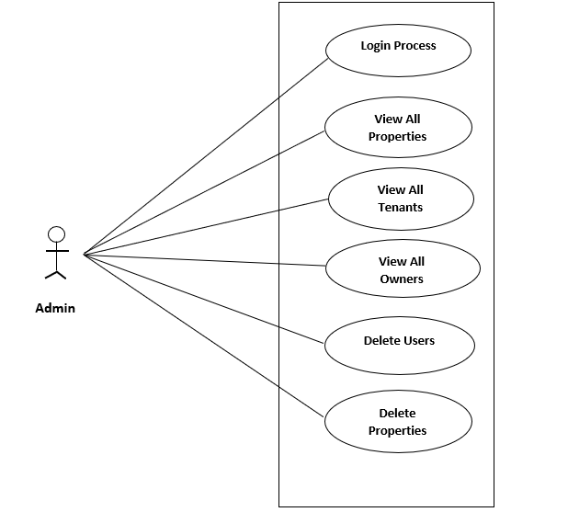

*Fig. Use case diagram for admin*

1. In Admin use case diagram Admin is the Actor.
2. Admin can handle following use cases:
3. Login
4. Show All Properties
5. Show all tenants
6. Show all Owners
7. Delete users
8. Delete properties
9. Manage transactions
   * 1. **Tenant :**

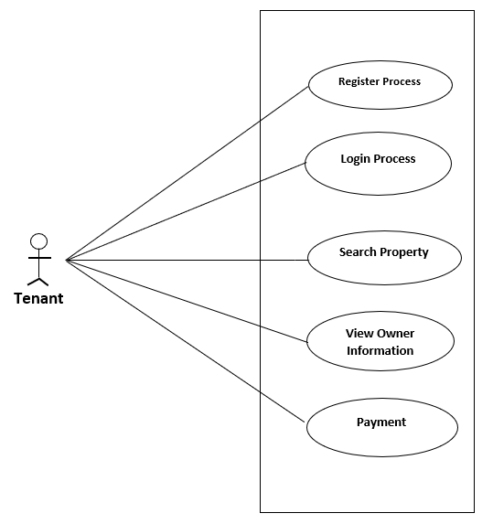

*Fig. Use case diagram for Tenant*

1. In Tenant use case diagram Tenant is the Actor.
2. Tenant can handle following use cases:
3. Register
4. Login
5. Search Property
6. Request for Owner Info
7. Pay for Subscription
   * 1. **Owner :**

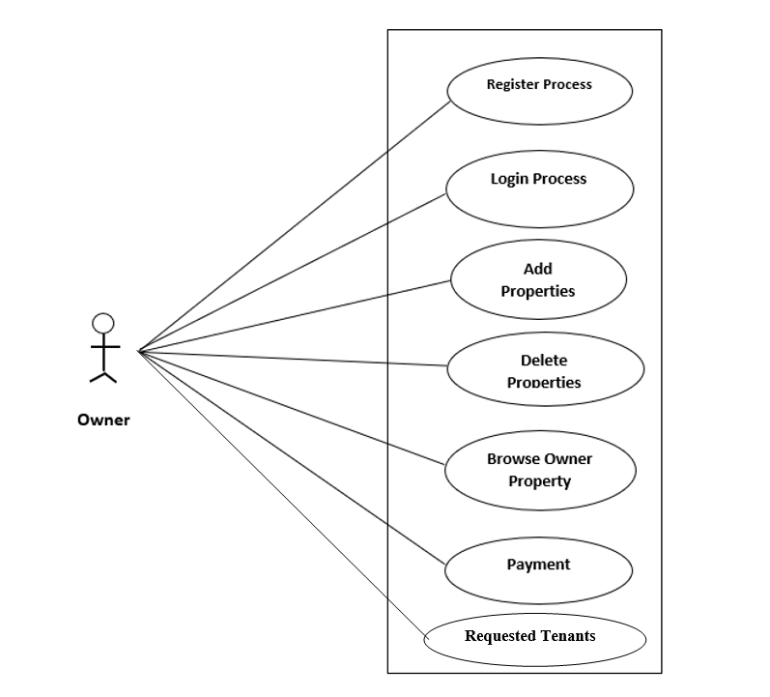

*Fig. Use case diagram for Owner*

1. In Owner use case diagram Owner is the Actor**.**
2. Owner can handle following use cases:
3. Register
4. Login
5. Add Property
6. Remove Property
7. Browse Properties
8. Browse own Property
9. Pay for Subscription
10. Requested tenants